Merrimack River District Community Workshop #2 April 9, 2022

Notes

Station 1, Visual Preference Survey, Facilitator Notes (Aishwarya Kulkarni)

- The buildings in MRD have varied elements and features
- Love the 2nd period and colonial architecture on the Main Street
- The first part of the Hat Factory has nice brickwork; Second part is very utilitarian
- Amesbury downtown has many brick buildings and adding the same type of buildings in the MRD will make reduce its uniqueness
- Wildlife Corridor is aesthetically good and needs to be preserved
- The vacant land at Trader Alan’s can be developed as a public space
- Secure the area to be green
- Areas/Buildings that need to be preserved:
  - Lo’s Boat Shop
  - Union Congregational Church
  - Entire Point Shore area
- Alliance Park is good, but very small. The stacked boats in front of the park block the views.
- Everything along the river is good and needs to be preserved.
- Need to increase walkability in the area
- Corner of Main Street and 110 looks okay. Needs some green space.
- Brick sidewalks are not practical
- Create a little node or a coffee shop at Point Shore (Many people talked about wanting a coffee shop in that area).
- Need more green space at Elm and Macy Street
- Bike trails are good, but they will slow things down on the Main Street
- Design parklets along the river
- The Village at Baileys Pond is not good. There is nothing unique about the development. It could have been developed anywhere in MA.
- Solar panels are good. Need to think big. Consider solar roads and sidewalks
- Splash pool at 110 and Trader Alan’s would be a good investment.
- New developments should preserve the New England Character of the city. Contemporary architecture is a big NO.
- Design convenience stores that look like houses
- 110 could be redesigned completely as a mixed-use street
- Need to preserve the wildlife habitat in the area
- Outdoor dining is good, but the sidewalks should be made up of big pavers
- Small two to three story buildings are preferred
- Trader Alan’s site could be used for ice skating
- Pickle ball courts at Trader Alan’s
- Love the antiquity of the houses. Stone and brick architecture looks good.
- Most people have done a good job of renovation
- Need mixed-use development at 110 and Elm Street
- Mixed-use at Pond View/Not on Clark’s is favorable
- No splash pads. Existing at Town Park…. maybe near Burger King
- More housing for families and younger population. Needs to be visible from the street. Do not design houses behind tall buildings such as the Hotel or Condo buildings.
- Don’t want traffic at 110 because it will go to Clark’s.

Station 2, Transportation, Facilitator Notes (Jeff Maxtutis)

Group 1
- Provide speed feedback radar signs
- Provide raised crosswalks at Lowell’s Boat Yard and Alliance Park
- Make Rocky Hill Rd 1-way NB
- Install no Right Turn on Red sign on Rt. 110 eastbound onto Clark’s Road and southbound Merrill St onto Evan’s Place
- Request MassDOT prohibit trucks on Main St
- Tight curve noted on Clark’s Road southbound
- Any new development onto Clark’s Road should only allow to exit northbound onto Clark’s Road
- Provide public transit to area

Group 2
- Over-arching theme – Encourage traffic to use Rt.110
- Raised intersection or crosswalk at Alliance Park
- All-way Stop signs at Main & Merrimac
- Make Main St 1-way eastbound – No Left turn from the signal at Main/Merrill onto Main WB
- Merrimac – make 1-way eastbound
- Provide bike lanes on both sides with the extra width that the 1-ways provide, Main, Evans, Place, Pleasant Valley Rd
- Make Rocky Hill Rd 1-way NB

Group 5
- Main St is a scenic drive for motorists, encourage cut-thru traffic to use Rt. 110 vs Main
- Make Merrimac 1-way eastbound (no everyone agreed to this)
- Some, but not all, thought a raised intersection or all-way Stop at Main/Rocky Hill and Main/Clark’s Td were needed
- Narrow Evan’s Place with a sidewalk between I-95 and Clark’s Road

Group 6
- Raised crosswalks at Lowell’s Boat Yard, Alliance Park, and at Main and Evans Place
- All-way Stop at Main and Merrimac
- Make Main St 1-way eastbound with bike lanes, better for residents to have 1-way eastbound
- Tight turn from Clark’s Rd onto Man
- Snow is plowed onto sidewalks in winter
- Make Rocky Hill Rd 1-way NB and Clark’s Rd 1-way southbound

Station 3, Open Space, Facilitator Notes (Tyler Maren)
- The Merrimack riverfront was universally considered an important natural resource and outdoor recreation location.
- Alliance Park and the municipal boat launch were commonly identified as the only two public spaces along the riverfront. Groups identified a series of privately-owned parcels along the Merrimack that comprise the largest remaining undeveloped stretch of riverfront. They valued the scenic views and were concerned about the potential for development.
- Several participants valued kayak/boat access in the Merrimack and Pow Wow rivers and noted that access could be improved and expanded.
- Most groups noted that the volume and speed of traffic along Main Street were significant barriers to increased use of those spaces by cyclists and pedestrians.
- Sidewalk quality, especially along the Merrimack Street portion of the riverfront, was also identified as a problem. Despite showing a bike path on the map, participants stated that most roads in the area were not safe to bike on.
- Several participants stated that they would like to preserve as much natural land as possible around Bailey’s Pond.
- Most agreed that the former Trader Alan’s property would be a good location for outdoor recreation activities, although some thought this should be combined with commercial or industrial development.
- Multiple participants identified a conservation area off Point Shore Drive as an underutilized piece of open space that not enough residents were aware of. They identified an upcoming comprehensive permit project as an opportunity to connect the Point Shore Drive conservation area with trails and open space further north.
- The local wildlife was identified as a valuable resource that draws people to the area.
- Multiple groups wanted better pedestrian and bicycle access to the new Amesbury visitor center to the south, which would then connect to Deer Island and Newburyport.

Station 4, Riverfront, Facilitator Notes (Jack Sweeney-Taylor)
Sense of Place, Neighborhood
Perceptions of residents of riverfront area
- Feel it is a road, not a neighborhood
  - Sidewalk is not safe, hospitable
  - Ends at old Main Street
  - Heavy traffic – lives at back of house to get away from traffic noise
- Love the neighborhood, wish to share with others
Perceptions of others
- Resident of elsewhere in Amesbury loves the riverfront, but only passes through on his way to Newburyport, does not visit – “I don’t want to intrude”

Cultural & Historical Resources
Places
- Massachusetts Historical Commission inventoried properties
  - Vernacular residential architecture of the 18th Century/Industrial Revolution
- Hat factory – historic, but bad signage, not inviting
- Alliance Park
  - Valued public parking and space
  - Additional parking at Union Congregational Church
  - Forms bookend, along with Lowell’s Boat Shop, of walkable area of riverfront
- Lowell’s Boat Shop
  - Represents legacy of shipbuilding along Main Street
    - Lowell’s once had 7 buildings, but burned down
    - Several other shops along Main Street and up Pow Wow River
  - Threatened by encroachment from nearby development
  - Not enough parking – parking at LBS is valued by local residents for house parties, etc.
  - Forms second bookend, with Alliance Park/UCC, of walkable area of riverfront
- Property near LBS – land fill “bump out” onto river for coal factory for coal barges
- Bailey’s Bridge
  - Problem that trucks hit top of bridge
- Main Street also historically used as lumber yard for shipbuilding
- “Ferry District” on Merrimac Street
  - Ferry landing at Alliance Park?
  - Water Treatment Plant once had a plaque commemorating George Washington’s crossing of Merrimack River by Ferry
    - Source of name of “Pleasant Valley”??
- Branch of Main Street also once had a trolly
- Boat Barn @ Old Main Street
- Smith’s Chain Bridge Station
- Deer Island
- Garrison Rail Trail
- Bartlett Museum and MB Eddy Museum
- Local Historic Burial Ground – Webster’s – Salisbury Point Cemetery
Events
- Lowell’s Boat Shop
  - 3 main events: “Spring Fling”; “Fall Fest”; holiday party
- Union Congregational Church
  - Women’s Group events
  - Road races with other non-profits, ex: Lazarus House
- Private fall harvest party at open space along river (“Bailey’s Green”)

Public Access to River
Physical Access
- Municipal boat launch
- Lowell’s Boat Shop, to some extent
- Marina, for private members
- Bailey Pond
  - Fishing and ice skating
Visual Access
- Alliance Park
  - Valued view and seating
  - But view block by large boats sometimes
- Union Congregation Church (parking)
- “Bailey’s Green”
- Lowell’s Boat Shop
- Hatter’s Point Boardwalk

Streetscape Improvements
Traffic
- Eliminating on-street parking would make traffic worse
- Narrowing road for traffic calming
Sidewalks
- “All need to be redone” along Main Street/Point Shore
- Sidewalks on Merrimac, end at Pleasant Valley Rd
- Sidewalks from V.C. to Lowell’s widened
- Crosswalk safety concerns
  - Drivers ignore crosswalks
    - Add lights to alert cars to stop
  - In some cases, crosswalk leads to no sidewalk, just to someone’s front yard
Parking
- Some feel there are sufficient parking spaces
- Others feel more spaces at Lowell’s or other strategic places would help people enjoy riverfront
  - Problem of no space to add parking
Trees
- Don’t add trees to river side of road, would block view
Other
- Bury utility lines
- Maintain “Bailey’s Green”
Bailey’s Bridge
- Problem that trucks hit top of bridge

Station 5, I-95 Gateway, Facilitator Notes (Peter Flinker)

This station used a simple 1”=40’ scale model of the I-95 Gateway to explore opportunities for infill development, traffic improvements, better pedestrian connections and other possibilities. Participants were asked to identify what is working well and needs to be preserved and what’s broken and needs to be fixed. They were asked to identify opportunities for improvement, including:
- Which improvements would make it easier or more enjoyable to move through the area on streets, sidewalks, paths?
- Which buildings could be expanded, redeveloped, replaced? What would these buildings ideally be used for?
- Where could new buildings be added? What would they ideally be used for?
- How could existing outdoor spaces be improved? Where could new outdoor spaces be added, and what would they be used for?
Given the time limitations, the conversation focused on the question of appropriate future uses and arrangement of buildings, parking and open space at the central intersection, and whether development of the area could create an attractive gateway to Amesbury. There was a secondary focus on future uses for the lots to the north and south of the intersection, with the assumption that these would likely be redeveloped for housing. Groups did not address in detail current proposals by Minco and others for residential development off Clarks Road and Elm Street, but were asked how these might be better connected to other parts of the district, and how these potential development projects could best relate to the gateway area in terms of the size and scale of buildings and the location of roadways and parking lots.

As described in the following summaries of each group’s results, there was clear agreement on an overall approach to the future of the I-95 gateway. Some shared redevelopment principles include:

- Redevelop street frontage surrounding the intersection of Rt. 110, Elm Street and Clarks Road with attractive 2-1/3 to 3 story mixed-use buildings.
- Keep the scale of buildings relatively modest along the frontage and put larger apartments and other uses on deeper lots extending to the north and south.
- Move parking lots, gas pumps and other automobile-related uses to the rear.
- Consolidate curb cuts, share driveways, and link across lot lines in the rear of parcels to improve vehicular circulation.
- Create shared parking lots serving multiple buildings, including adjoining parcels in different ownership.
- Create a consistent streetscape along the frontage of Rt. 110, Elm Street and Clarks Road with safe, continuous sidewalks, street trees and other landscaping.
- Create a safe North-South crossing of Rt. 110 for pedestrians and bicycles.
- Keep the MassDOT parcel at 110 and Elm Street as a public park or as the site of a visitor’s center.
- Explore provision of an additional park on Clark’s Road to serve neighborhood residents.

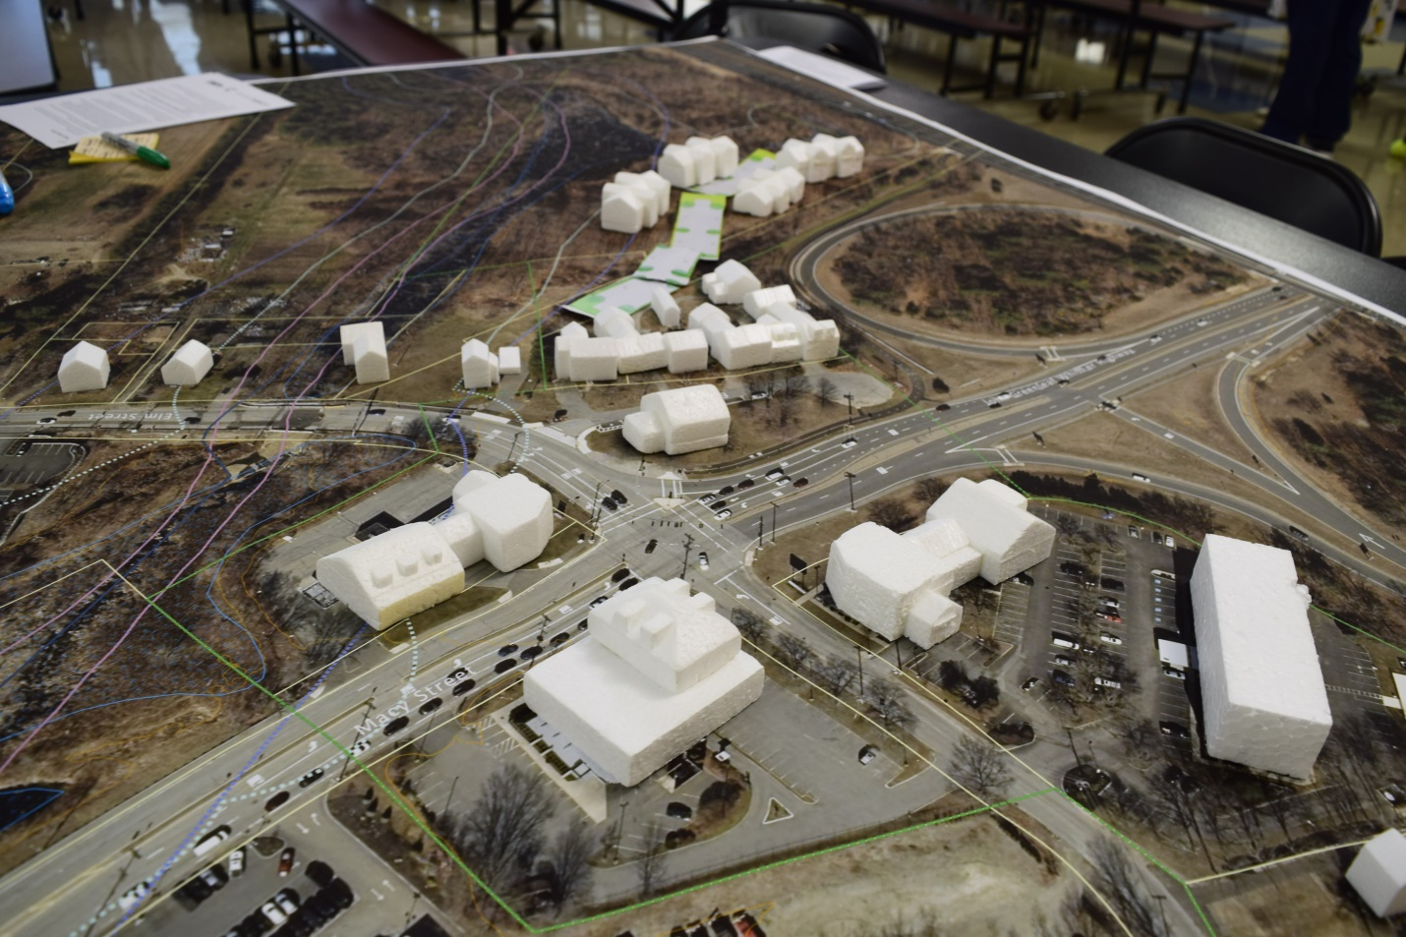
Individual Group Results: Group 5
This group supported redeveloping the four corners of the intersection to create a more attractive gateway, with a larger footprint of 2-1/2 to 3 story buildings replacing Friendly’s, Burger King and the Gas Station. Parking would be moved to the rear so that you see buildings rather than parking lots from the road. If a building would be necessary on MassDOT’s corner parcel, they suggested a visitor’s center and a small park which could welcome people to Amesbury and provide a jumping off point to the rail trails. This group supported additional housing off of Elm Street to the North, with smaller scale townhouses or cottages in the front facing the park and larger residential buildings arranged to the rear, with parking hidden in between. This group pointed out the importance of improved connections to the Riverwalk and the Ghost Trail, as well as making it safe to cross Rt. 110 by foot and bike.

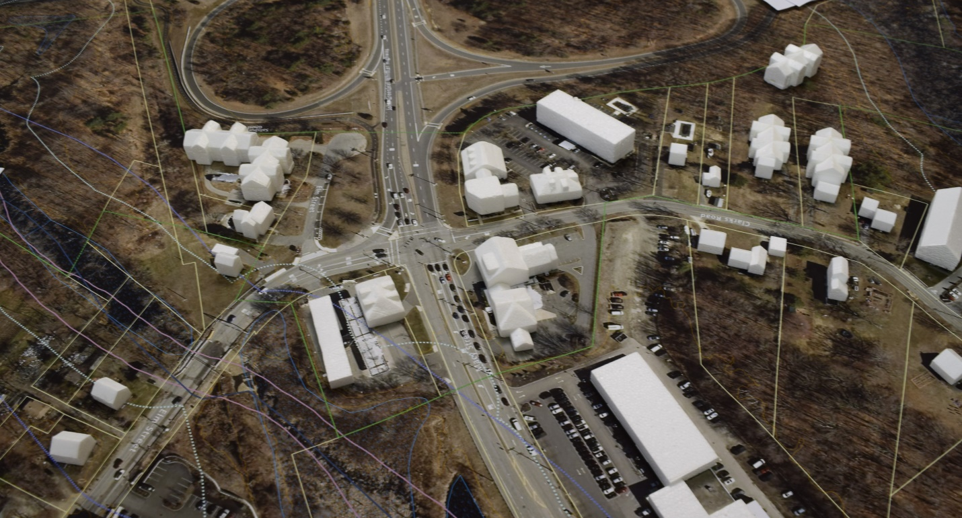

Group 2
This group also thought that new buildings along the Rt.110 frontage would serve to better enclose the street and create an attractive gateway off of 95. New buildings could take the place of Friendly’s and Burger King, with parking screened behind the buildings. Participants identified the scale and detailing of the new CVS and office building at the corner of Main Street and Rt. 110 as an appropriate scale for new buildings, generally no more than 2-1/2 or 3 stories. On the northwest side of the intersection (lower left in the image above) this group proposed rebuilding the gas station with a building on the corner and pump islands to the rear (sometimes known as “Gas Backwards”. On the Northeast corner the open space owned by MassDOT would remain as a park, and buildings along Elm Street could be replaced by larger apartments or town-houses. On Clark’s Road, three apartment buildings were placed roughly as planned under Minco’s current development scheme.

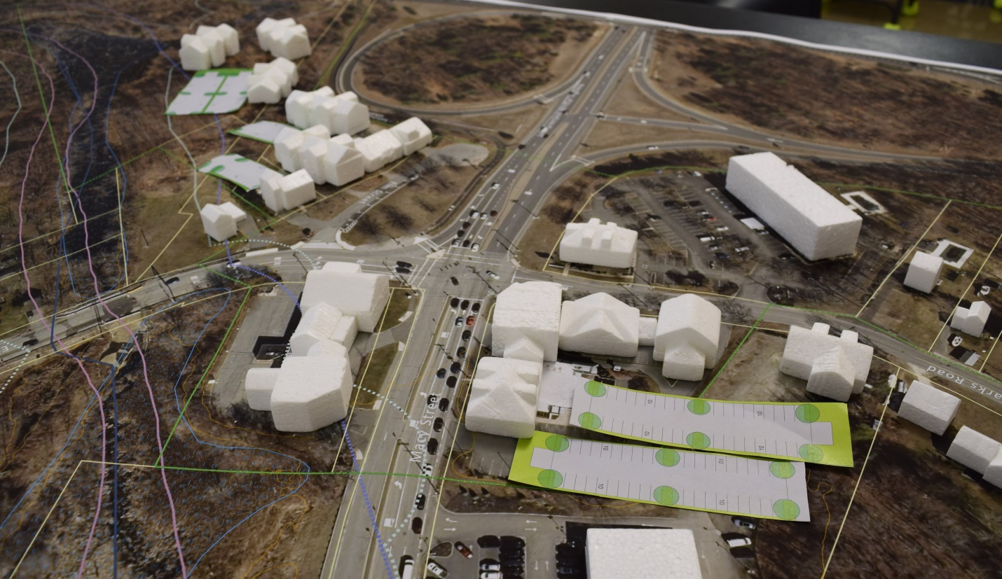

Group 6
This group focused on redeveloping the Gas Station and Burger King properties, with new mixed-use buildings along the Rt. 110 and Clarks Road frontage and parking flipped to the Rear. This included consolidating a corner of the Amesbury Chevrolet property into the redevelopment zone. This would allow extending development across a vacant lot along Clarks Road and could provide a larger area of parking in the rear that could be shared by all of the buildings. Participants noted the potential for redeveloping the gas station property to provide a more attractive façade facing Rt. 110, again with parking to the rear. They discussed the potential for a larger residential complex north of Elm Street, but recommended being careful to have smaller building facades along Elm Street with larger buildings hidden behind. They supported the idea of keeping the MassDOT parcel as a public park.
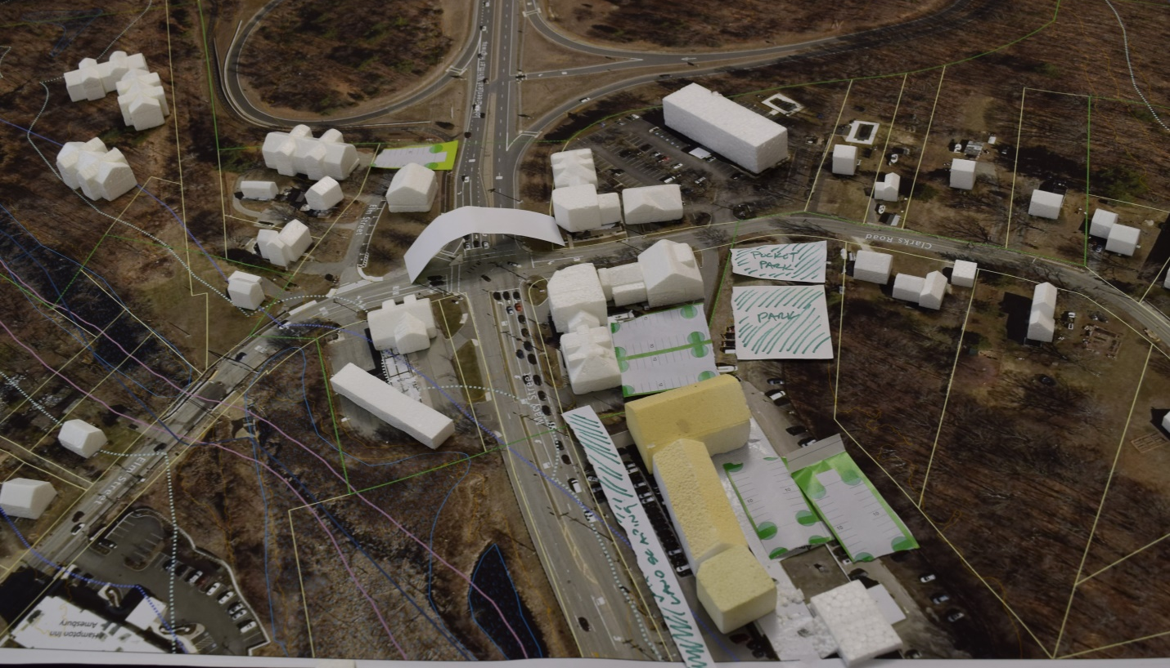

Group 3
This group supported construction of buildings around the intersection, with a scale similar to the CVS project down Rt. 110, which could improve the appearance of Rt.110 and serve as an attractive gateway to Amesbury. They suggested cleaning up the stormwater retention pond in front of the Carriage Town Marketplace and retrofitting the gas station by building a new structure on the corner and putting pumps to the rear, as well as adding electric charging stations. They proposed a new visitor’s center on the MassDOT parcel, with a parking lot on the end of Elm Street to serve visitors and the bike trail. They suggested keeping the existing structures on Elm Street and putting larger apartments or townhouse on the lot to the north, where they would largely be out of view. This group pointed out the importance of creating a safe crossing of Rt 110 for pedestrians, possible including a bridge across the roadway. They raised the importance of biking in this part of Amesbury, and the need to connect the Bike Trail to Point Shore, possible across the 29 Clark’s parcel to Point Shore Drive.

This group spent time discussing the future of the car dealership, and what could happen to that property if there is no longer a need for such uses in the future. One idea would be to redevelop the site for a larger medical or similar use, which would allow for a more attractive new building with landscaping along Rt.110, and putting parking in the rear. The corner of the car dealership property extending to Clarks Road could be converted into a park to serve the surrounding neighborhood and which could help to buffer residential areas along Clarks Road from the mixed use redevelopment and parking along 110.

Station 6, I-495 Gateway, Facilitator Notes (Dillon Sussman)
- Need to connect sidewalks and possibly bike lanes along Pond View Ave
- Desire for a trail/open space connection from Bailey’s Pond/Pond View Avenue to Margaret Rice Park
- 21 Pond View Ave is seen by many participants as a key open space opportunity, especially with development happening elsewhere in the MRD. Some phrased this as, “Bailey’s Pond Development doesn’t have enough open space, so the residents need open space here.”
- Desire for more trees. Some phrased this as mitigation for development elsewhere, “there have been so many trees cut down.” Others said trees are necessary to buffer adjacent houses or to improve look of Amesbury when entering the neighborhood from the north.
- Desire for active recreation uses. The following were mentioned by several groups:
  - Fenced Dog Park
  - Playground
  - Park
  - Playing fields
- Some interest in additional housing
  - Mixed opinions about the appropriate scale of housing. Housing types that were cited as appropriate
    - Cottages
    - Single-family like adjacent parcels
    - Townhouses
    - Small multi-family
    - Multi-family
    - Some participants cited housing crisis and need for affordable housing
    - One person suggested that 21 Pond View Ave could be used as open space so that surrounding neighborhood could handle additional housing (increased density)
- Commercial Uses
  - Commercial uses were supported by some but were not generally as supported as open space or housing uses
  - One participant cited the need for tax revenue
  - Several groups said that there is already industrial/commercially zoned land along Hunt Road. 21 Pond View property was seen as less suitable or unnecessary for commercial/industrial use.
  - When commercial was supported, the following uses were preferred:
    - Office
    - Mixed use
    - Small scale restaurant or retail—serving Maple’s Crossing was mentioned.
    - Some members of one group supported the idea of a heavily landscaped office park campus
    - One person suggested a grocery store (Trader Joe’s size)
- Municipal Uses
  - One group suggested municipal uses for the site:
    - Fire station
    - Greenhouses to be used by schools and seniors
    - Natatorium
    - Senior facility
- Most participants were interested in combining the 21 Pond View Ave parcel with the Auto salvage yard if possible. Some expressed concern about the amount of clean up that would be needed and what use restrictions there would be.
  - When participants explored use of auto salvage yard they usually suggested smaller scale housing (like a cottage community) on the interior of the parcel, open space, or parking. More intense housing or commercial space fronting Martin Road South was not suggested.
- Parking. Participants supported hiding parking in the lot interior or along the solar field edge. Some suggested that parking needed to be minimized so that parking didn’t dominate the site
- Overall Design principles
  - Make Pond View Ave more pedestrian and bicycle friendly
  - Signal to drivers that they are entering a neighborhood
  - Line street with buildings. Put smaller structures at front of street, put taller ones behind (if taller structures are going to be on site).
  - Connect from Pond View Ave to Margaret Rice Park
  - Buffer adjacent residential neighbors
  - Locate public commercial spaces in the northeast corner (if shadow limitations allow)
  - Connect to auto salvage yard. Develop a cohesive design for all uses on both properties.

Group 1 Notes by Participant
Participants:
- Greg Noyes
- Alex Loth
- Janet Wills
- Linda Vialobos
- Carol Finn
- Patty Hoyt
- Sheila Maurer

No Notes were taken by the volunteer

Group 3, Notes by Participant
Station 3, Open Space
Important spaces
- Alliance Park
- Lowell’s Boat Shop
- Boat Launch
Potential Connections
- Connect Margaret Rice Park to sidewak on Beacon through 21 Pond View Ave or Solar Field
- Important wildlife corridor along Pow Wor River and connecting to cemetery
- Important to preserve habitat and open space because there is not much in this area

Station 6, Modeling I495 Gateway/Pond View Ave
Pond View
- Disposition Committee says office/light industrial uses
- What does this group think is appropriate
Herb
- path to connect to Margaret Rice Park
- Open Space and Multifamily
Linda
- No more big buildings
- Lots of landscaping. Must be green
- Quiet things down
- Maybe just homes and open space
Cory
- Playing fields, playgrounds, park
- Cottages
- Sidewalks along Pond View Ave
John
- Likes the Cory plan. Can we connect the parcel behind (salvage yard)?
- Perhaps increase the density along Woodridge and Martin. Using 21 Pond View Ave as the neighborhood open space would allow increased density on those streets
Note from group. There is lots of industrial/office zoned space along Hunt and Middle Road. Don’t feel like it is necessary to have those uses on Pond View Ave

Station 1, Visual Preference Survey
- Rezone point share so very small businesses (sandwich, coffee, etc) are allowed
- Opportunity for winter recreation on Bailey’s Pond
- Hat Factory—public coffee bar?
- Small scale commercial on Point Shore
- Opportunity to green and improve aesthetic along Route 110

Station 5, Modeling I-95 Gateway
Linda
- Green Spaces maintaining green or reducing pavement
- Make 110 more attractive
John
- Visitor center with parking for trail
Herb
- Clean up stormwater retention pond at CarriageTown Marketplace
- Gas Station could it be cleaned up and maybe more pretty. Maybe gas in back with electric chargers
- More like the corenr of Main and 110 (CVS, Cumberland Farms, etc).
- Bike Trail to tie to Point Shore
- Need sidewalks. Maybe a bridge over 110
- Have more mixed use (restaurant, etc.) on corner with parking in back. Maybe a park.
- Car dealership will go away eventually. When car dealership is gone, landscape along the road, keep it commercial, maybe urgent care/medical
- Biking is important in this part of Amesbury, connecting
  - Maybe bike path through from Point Shore across the 29 Clark’s parcel to Clark’s Road up to an underpass that connects to other bike paths

Group 4, Notes by Participant
Sally Nutt, resident
Tina Broderick, Cons Comm, resident, Lowell’s Maritime Foundation
Brad Matthews, Whitehall Road resident
David Frick, Planning Board

Station 4, Riverfront
- Lots of traffic
- On Main Street sometimes doesn’t feel like a neighborhood
- I don’t live on Main Street and don’t feel like I could stop and walk in that space

Historical Site (yellow post its)
- Alliance Park
- Union Congregational Church
- Lowell’s Boat Shop
- Point Shore
- Marrimac Hat Factory

Public Access
- Public Boat Launch
- Alliance Park
- Visitor … (unintelligible)

Station 1, Visual Preference Survey
No notes

Station 6, Modeling I-495 Gateway, Pond View Ave
- Zoned for office park, approx 5 ½ acres usable space
- Desired uses
- Fields
- Green space
- Small coffee shop
- Important to have green space
- 1-3 story storefront
- Traffic is a consideration for neighbors

Station 3, Open Space
- Sidewalk missing on Evans Place, very important to remedy
- Bike lanes on Point Shore could be traffic calming
- Improve sidewalks on Merrimack treet
- Traffic consuleration (?) to make commuters
- Beacon Street-sidewalks are not adequate
- Pedestrian safety
- Point shore—commuter road vs residential road
- Important—commuters are driving too fast. Pedestrian safety issue.
- Margaret Rice Park of Martin Rd should be utilized as something. Consider mountain bike trails.

Group 5, Notes by Participant
Station 5, Modeling I-95 Gateway
- Concern about better Riverwalk/Rail Trail connection
- Problems in I-95 gateway
  - Hotels & inns
  - Slowing down drivers to allow for more walkability-pedestrian bridge
  - How do we encourage walking
- Organize around reiverwalks rather than cars
- Landing place at existing gas station to provide a marketplace to stop. Sporting equipment, visitors information, café as a connection point for Ghost Trail and Rail Trail & Clark’s Road.
- Middle housing options to allow for cottage style along Elm Street wrapped by Ghost Trail
- Townhouses on 110 with larger apartment in the rear
Station 2, Transporation
- Residents only signs are exclusionary
- Concern about speeding
- One way Main Street
- Bump outs or raised intersections to slow down traffic
- Would disintegrate the historic integrity of the neighborhood streetscape
- Make people feel they are driving through a parking lot at Lowell’s
- Narrowing visuals at Lowell’s
- Narrowing of Evan’s Place to slow traffic and add broad sidewalks
- Encourage pedestrians from Visitor Center to continue to Lowell’s

Station 4, Riverfront
- Indigenous sites
- Shipbuilding
- Cemetery
- River views

Station 1, Visual Preference Survey
- Agreement that 110/Elm has different requirements from Point Shore
- No additional commercial development in Point Shore
- No additional housing on Main Street, Point Shore
- Middle Housing on Elm/110
- 110/Burger King low heights under 3 stories
- No brick on Main Street, Ferry District
- In Clark’s/Elm housing be sure to include space for families to play

Group 6, Notes by Participants
Station 6, I-495 Gateway/Pond View Ave
- 6.8 Acres available, owned by City
Uses desired by group
- Fenced dog park with housing and a play space for kids
- Bike lane? Connecting eventually to Main Street?
- Balance of market rate and supportive/affordable units
- What is the balance between housing and business space?

Station 3, Trails and Open Space
- Linking the bike path
- One way on Main Street to accommodate bike lane and wider sidewalk
- Re-route traffic to 110 and Merrill Street away from Main St
Station 6, I-95 Gateway
- Brownfield development [grayfield?] is preferred over greenfield development
- Add units to the abandoned Mill Buildings downtown by the Barewolf Brewery

Station 2, Transporation
- Raised speed bumps/crosswalks
- One way on Main Street
- Bike lane
- Improved recreation
- Traffic diversion
- Improved safety

